Zomato Sales & User Analytics Dashboard
1.Project Overview
This project provides a comprehensive analysis of Zomato's operations, including sales, orders, customer behavior, and city-wise performance. The insights are derived from transaction and user data, helping identify growth opportunities, customer retention challenges, and high-performing regions.
2. Key Metrics
- Overall Performance:
- Total Sales Amount: ₹987M
- Total Orders: 150.28K
- Overall Rating: 148.45K
- Total Users: 100K
- Active Users: 77.93K
- Category-wise Performance:
Category | Sales | Ratings
Veg | 156K | 731K
Non-Veg | 140K | 316K
Others | 14K | 1K
- Yearly Performance:
- Highest sales year: 2019 – ₹1002K
- Top-performing city (by sales): Electronic City, Bangalore – ₹0.36M

User Insights
- Age Group with Highest Users: 23 years old (18.8K users)
- Gain Customers (Current Year vs Previous Year): 11.64K
  - Male: 6.56K
  - Female: 5.08K
- Lost Customers (Current Year vs Previous Year): 33.04K
  - Male: 18.92K
  - Female: 14.12K

City-Level Insights
- City Sales Amount: ₹368K
- Sales Quantity: 367
- Orders: 0.10K
- Overall Rating: 148.45K
Example: Akola
- Sales: ₹0.37K
- Ratings: 0.10K
- Users: 0.10K
- Orders: 100
- Lost Orders: 100
3.📷 Screenshots
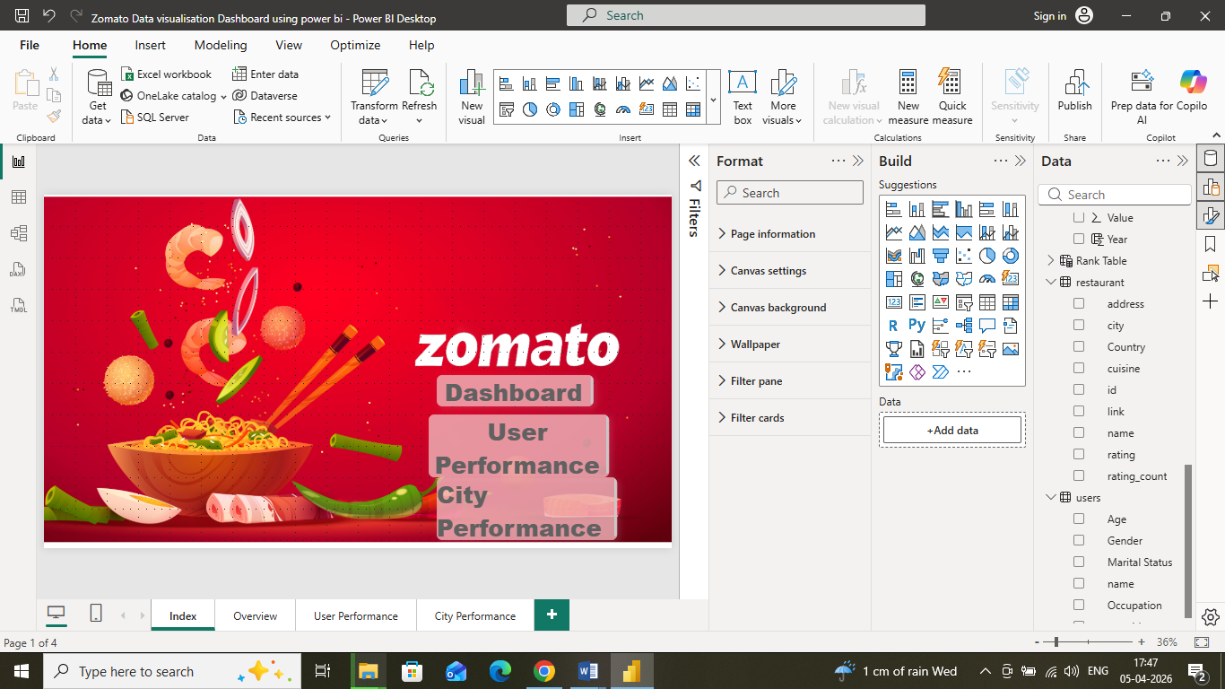
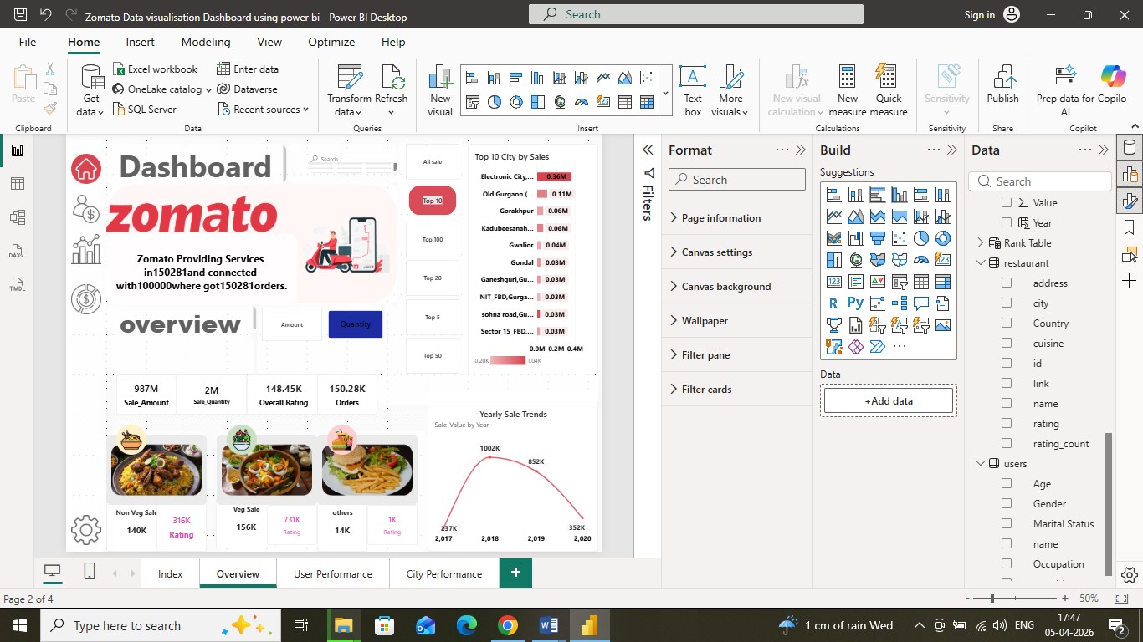
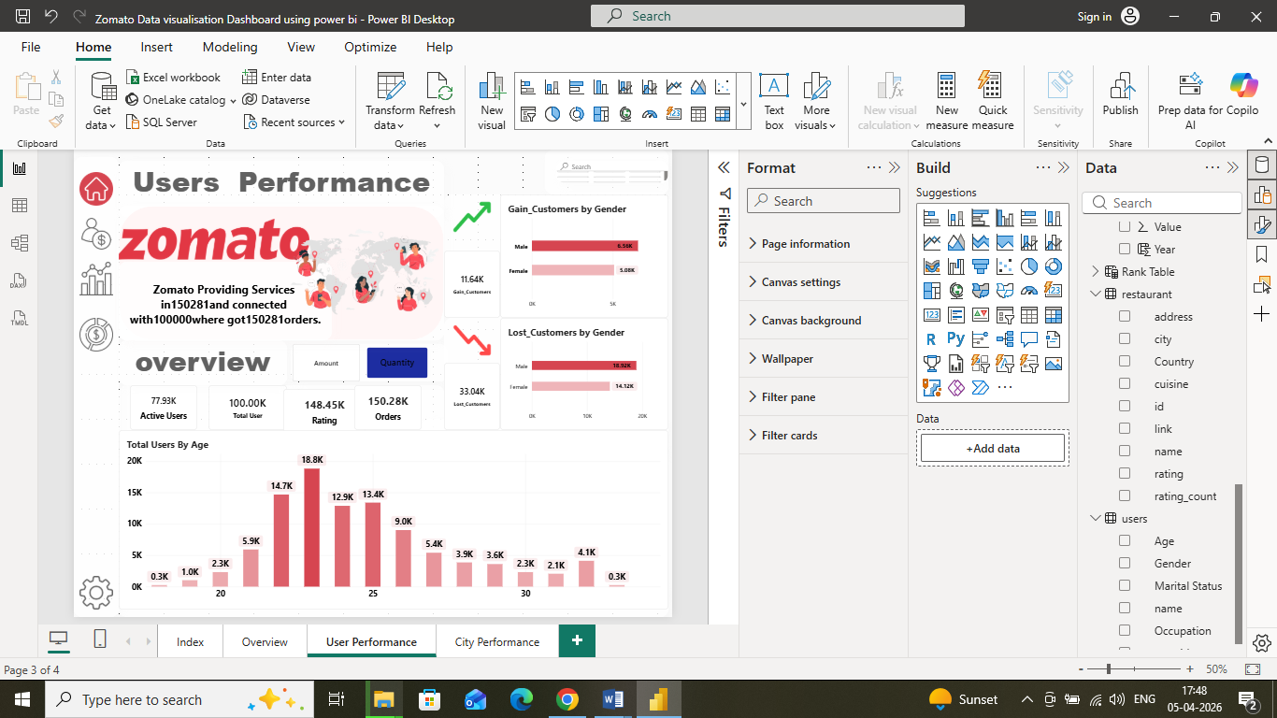
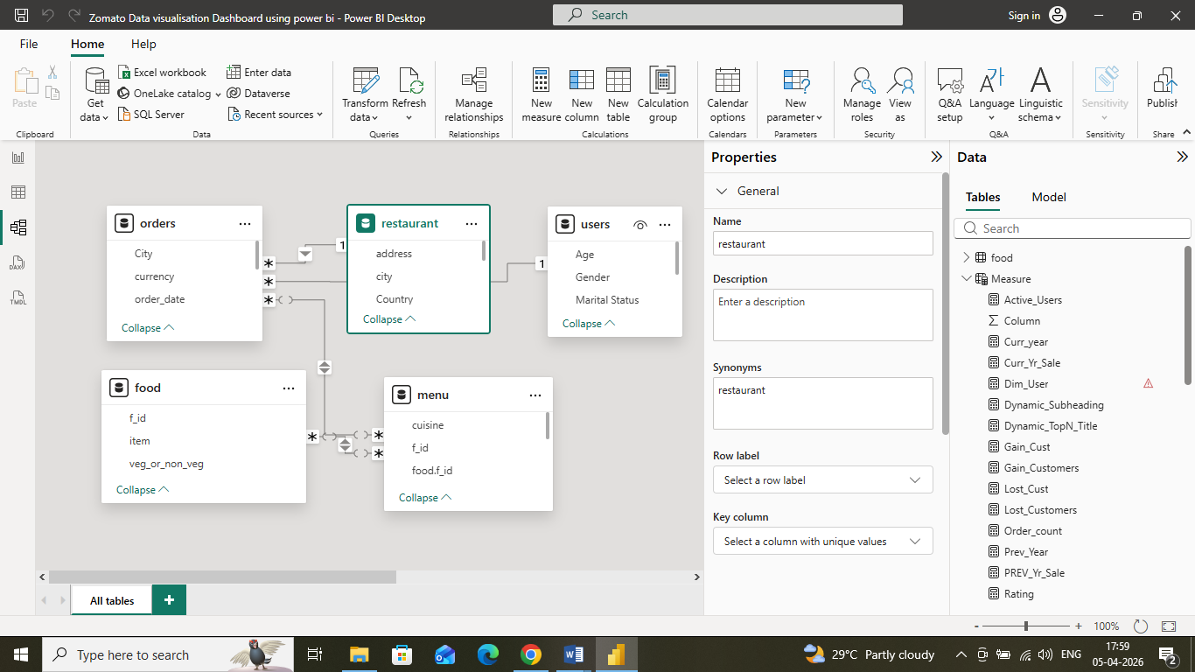

4. Data Model & Features

🔗 Data Sources
  - orders table – Transactional order data
  - users table – Customer demographic and behavior data
  - restaurant table – Restaurant ratings
  - Food table-Category
  - Menu table-Relatationship between Menu and Food

⚙️ Features Implemented
- ✔️ Data Modeling (Relationships)
- ✔️ DAX Measures & Calculations
- ✔️ Dynamic KPIs
- ✔️ Bookmark Navigation (City)

5.DAX Measures
Sale_Value=SUM(orders[Value])

Year = VALUE( FORMAT(orders[order_date],"yyyy"))

Rating_count=COUNT(restaurant[rating])

Order_count=COUNT(orders[order_date])

Rank Table =
DATATABLE(
"Sort", INTEGER,
"Type", STRING,
"NO", INTEGER,
{
{0, "All sale", 0},
{1, "Top 5", 5},
{2, "Top 10", 10},
{3, "Top 20", 20},
{4, "Top 50", 50},
{5, "Top 100", 100}
}
)

Dynamic_TopN_Title =
VAR selectRank =
SELECTEDVALUE('Rank Table'[Type], "All sale")
RETURN
selectRank & " City by Sales"

Dynamic_Subheading = "Zomato Providing Services in"&COUNT(orders[City])&"and connected with"&DISTINCTCOUNT(users[user_id])&"where got"& COUNT(orders[user_id])& "orders."

TopN_sale =
VAR SelectedRank = SELECTEDVALUE('Rank Table'[NO], 0)
VAR RankValue =
RANKX(
ALLSELECTED(orders[City]),
[Sale_Value],
,
DESC,
DENSE
)
RETURN
IF(
SelectedRank = 0,
[Sale_Value],
IF(RankValue <= SelectedRank, [Sale_Value], BLANK())
)

User_Count = DISTINCTCOUNT(users[user_id])

Active_Users = DISTINCTCOUNT(orders[user_id])

Curr_year = 2020

Prev_Year = [Curr_year]-1

Curr_Yr_Sale = VAR YR=[Curr_year] RETURN CALCULATE([Sale_Value],orders[Year]=YR)

PREV_Yr_Sale = VAR YR=[Prev_Year] RETURN CALCULATE([Sale_Value],orders[Year]=YR)

Gain_Customers = VAR Filters_users=FILTER(SUMMARIZE(users,users[user_id]),AND([PREV_Yr_Sale]<=0,[Curr_Yr_Sale]>0)) RETURN CALCULATE([User_Count],Filters_users)

Lost_Customers = VAR Filters_users=FILTER(SUMMARIZE(users,users[user_id]),AND([Curr_Yr_Sale]<=0,[PREV_Yr_Sale]>0)) RETURN CALCULATE([User_Count],Filters_users)

Rating Count by City = COUNT(orders[City])

Gain_Cust =
VAR UserTable =
SUMMARIZE(
users,
users[user_id],
"PrevSale", [PREV_Yr_Sale],
"CurrSale", [Curr_Yr_Sale]
)
RETURN
COUNTROWS(
FILTER(
UserTable,
[PrevSale] <= 0 && [CurrSale] > 0
)
)

Lost_Cust =
VAR UserTable =
SUMMARIZE(
users,
users[user_id],
"PrevSale", [PREV_Yr_Sale],
"CurrSale", [Curr_Yr_Sale]
)
RETURN
COUNTROWS(
FILTER(
UserTable,
[CurrSale] <= 0 && [PrevSale] > 0
)
)

6.Business Insights & Recommendations
- Customer Retention Focus:
  - High number of lost customers (33.04K) indicates a potential churn issue.
  - Action: Implement loyalty programs, personalized promotions, and targeted engagement campaigns to retain users.
- City-Level Optimization:
  - Some cities like Akola show low sales and high lost orders, suggesting operational inefficiencies or low awareness.
  - Action: Strengthen local marketing efforts, optimize restaurant partnerships, and analyze user preferences in these regions.
- Category Performance Optimization:
  - Veg category shows higher ratings than Non-Veg, suggesting user preference trends.
  - Action: Increase promotions and offerings for Veg dishes in high-demand areas.
- High-Potential Demographics:
  - Young users (around 23 years old) form the largest segment of active users.
  - Action: Develop targeted campaigns, mobile-first features, and referral programs for this demographic.
- Top Cities Strategy:
  - Focus on top-performing cities like Bangalore to maximize revenue growth.
  - Consider expanding delivery network and restaurant partnerships in these regions.

7.Conclusion
The Zomato Sales & User Analytics Dashboard provides a comprehensive view of business performance across cities, categories, and customer segments. Key takeaways include:
- Sales & Orders: The platform generated ₹987M in sales with 150.28K orders, indicating strong overall performance.
- Customer Behavior: While 11.64K new customers were gained, 33.04K users were lost, highlighting a significant churn issue.
- City & Category Insights: Certain cities and categories (like Veg dishes) are outperforming others, showing areas for strategic focus.
- Recommendations:
  - Implement retention programs for churned customers.
  - Optimize city-level operations in underperforming regions.
  - Enhance promotions for high-potential categories and demographics.
Overall, the dashboard enables data-driven decision-making, highlighting opportunities for growth, operational efficiency, and improved customer engagement.

Deepak Kumar Tekchandani
Power BI|DAX (Data Analysis Expressions)|Data Modeling|Data Cleaning & Transformation|Interactive Data Visualization
📧 deepakkumartekchandani@gmail.com
🔗 LinkedIn: www.linkedin.com/in/deepak-kumar-tekchandani-b7200a146
💻 GitHub: https://github.com/DTekchandani1/Zomato-Sales-User-Analytics-Dashboard.git

